About ICAEST-2026
The Third International Conference on Advances in Engineering, Science and Technology (ICAEST-2026) provides an international platform for researchers, academicians, industry professionals, students and innovators to present their latest research, exchange knowledge and discuss emerging developments in engineering, science, technology and management.
The conference aims to promote interdisciplinary research, innovation, collaboration and technology-driven solutions to contemporary challenges.

Who Can Participate

- UG and PG Students
- Research Scholars
- Faculty Members and Academicians
- Industry Professionals
- Scientists and Innovators
- Entrepreneurs and Technology Enthusiasts

- Objectives and Context

•Promote interdisciplinary research and innovation
•Share recent developments in engineering, science and technology and Management.
•Encourage academic and industry interaction.
•Provide a forum for research paper presentation and discussion.
•Explore technology-driven solutions to contemporary challenges.

ABOUT THE INSTITUTE
Brahmdevdada Mane Institute of Technology, Belati, Solapur was established in the year 2006, under the aegis of Kai. Amdar Brahmdevdada Mane Shikshan va Samajik Pratisthan, Solapur and is making its presence felt in States Technical Education. It is affiliated to Punyashlok Ahilyadevi Holkar Solapur University, Solapur. The Institution’s aim is to build a strong foundation of knowledge, pursue excellence and enhance creative disposition among Rural & Urban Students in an intellectually stimulating environment. The campus is spread over 10 acres of land with 2 Lakh sq. ft. of built up area having beautiful landscapes, excellent infrastructure, well equipped laboratories, state of art computer laboratories, central library and all the required amenities. BMIT provides peaceful ambience to the students for better Teaching & Learning process. The Institute is accredited by National Assessment and Accreditation Council (NAAC), Bangalore and offers four engineering disciplines—CSE, AI&DS, ENTC, Electrical and Mechanical Engineering, along with MBA in Management.

Institute Vision

To be recognized as the Centre of Excellence for Technical Education, Management Education and Technology Development.

Institute Mission

Empowering students through academic excellence and professional expertise to become innovators, entrepreneurs and ethical leaders who transform the country and the society.
Provide innovative solutions for industrial challenges while continuously contributing towards advancing technical knowledge.

Third International Conference on Advances in Engineering, Science and Technology
(ICAEST-2026)

17th -18th December 2026
Hybrid Mode

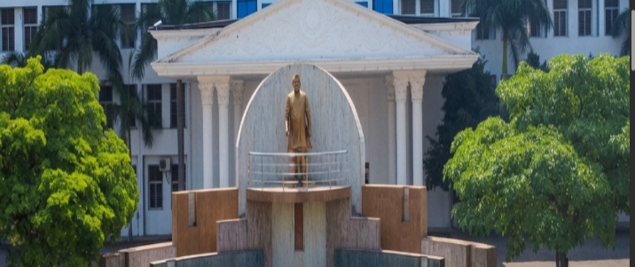
Organized by

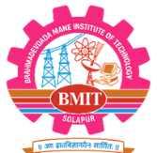

Brahmdevdada Mane Institute of Technology, Solapur
NAAC Accredited
Solapur-Mangalwedha-Kolhapur State Highway,
Belati - 413 002, Tal. North Solapur, Dist. Solapur(Maharashtra).
Affiliated to PAHSUS, Solapur
Email:bmit@bmssp.org,

Conference Topic

The conference covers following areas but not limited to

- Advances In Computer Science & Engineering (CSE)
- Advances In Artificial Intelligence & Data Science (AI & DS)
- Advances In Electronics & Telecommunication Engineering (ENTC)

Advances in Mechanical Engineering

Advances in Management

Advances in Nano Materials and Nano Technology

Advances in Environmental Sustainability

Advances in Physics

Advances in Chemistry

Advances in Applied Mathematics

Humanities

Registration Fees

Category | UG / Diploma Student Paper | PG / PhD Scholars | Academicians | Industry | Foreigner
Author /  Attendee | ₹ 1000 | ₹2000 | ₹ 3000 | ₹ 3000 | $50
Additional Registration | ₹ 1000 | ₹2000 | ₹2000 | ₹2000 | $30
Online mode | ₹ 500 | ₹ 1000 | ₹ 1500 | ₹ 1500 | $20

Registration is subjected to acceptance of paper.

Website link:

Patrons
- Hon. Dilip Mane (President, BMSSP)
- Hon. Dr. Prithviraj Mane (Vice President, BMSSP)
- Hon. Mrs. Jayshri Mane (Secretary, BMSSP)

Advisory Committee
- Prof. R. Y. Mane (Campus Director)
- Dr. R. D. Kulkarni (Principal)

Convener
- Dr. B.M. More – (Vice-Principal) (7387748484)
Co Convener
- Dr. A. V. Gaur – HOD MECH (8308845245)

Organizing Committee Members

- Prof. S. G. Kulkarni – VICE PRINCIPAL AND HOD AI & DS
- Prof. U. S. Dodmise. -HOD CSE
- Dr. K.S. Kazi - HOD ENTC
- Dr. P. K. Magdum - HOD Electrical
- Prof. M. L. Advani - HOD MBA
- Prof. A. A. Bhopale - HOD GSE
Important Dates

Abstract submission: 31st October 2026
Abstract Acceptance: after 5th November 2026

Full Paper Submission Deadline: 15th November 2026
Registration Deadline: 30th November 2026
Conference Dates: 17th - 18th December 2026

Schedule
Day, Date & Time | Activity
Thursday  17/12/2026  10:00am to 12:00 noon  Session 1 | Day-1 Inauguration  Keynote Speech
Thursday  17/12/2026  Session 2 | Keynote Speech  Technical Presentation
Thursday  17/12/2026  Session 3 | Keynote Speech  Technical Presentation
Friday  18/12/2026  Session 1 | Day-2  Keynote Speech  Technical Presentation
Friday  18/12/2026  Session 2 | Keynote Speech  Poster Presentation
Friday  18/12/2026  Session 3 | Panel Discussion and Valedictory

